TASK | Masking of odours in toilets
LOCATION OF USE | Workshop and Office toilets |  | Assessment  No |  | 023
PRODUCT NAME | Urinal Blocks
DESCRIPTION OF SUBSTANCE | Solid Yellow cubes which dissolve in water over a period of time
MANUFACTURER | MERLIN CHEMICALS  Unit 5, Passfield Mill Business Park,  Liphook,  Hants,  GU30 7RR
MANUFACTURERS CONTACT | 01428 751122
ASSESSOR | Martin Monaghan CMIOSH |  | Date |  | 04 12 25
TITLE | Health and Safety Consultant |  | Review by |  | 04 12 27
Personnel Performing Task  (Please list below)  Technicians/ Fitters/ Workshop Operatives |  | Time Spent  (Minutes/day)  As and when required, amounting to a few minutes per day | Training Given 
 |  |  | Yes

MSDS Revision Date | Hazard Statement
30/03/2015 | H315 Causes Skin irritation.  H318 Causes serious eye damage.  EUH208 Contains LIMONENE. May produce an allergic reaction.

Assessment to be conducted in Association with Hazard Data Sheets, a full current copy of which must be attached to this assessment.

Please denote the hazardous properties of the substances used in the task with a 

NEW INTERNATIONAL GLOBALLY HARMONISED HAZARD SYMBOLS
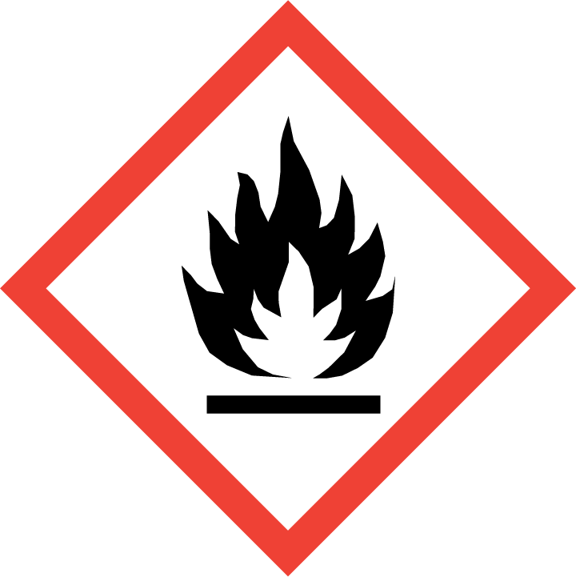 | 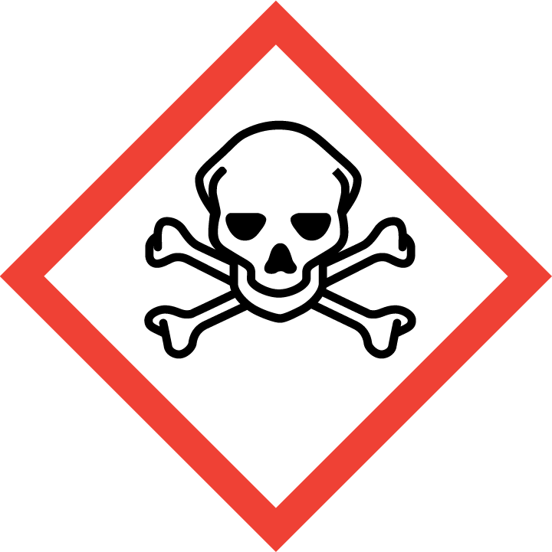 | 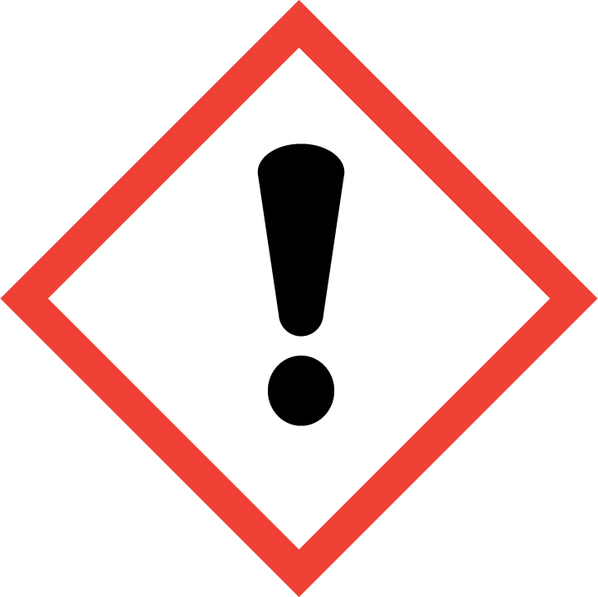 | 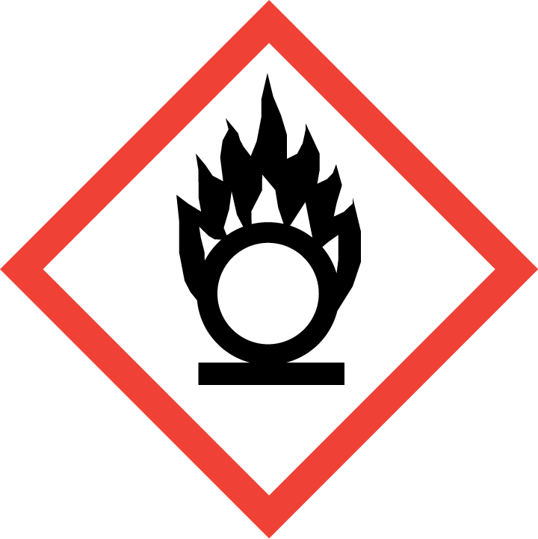 | 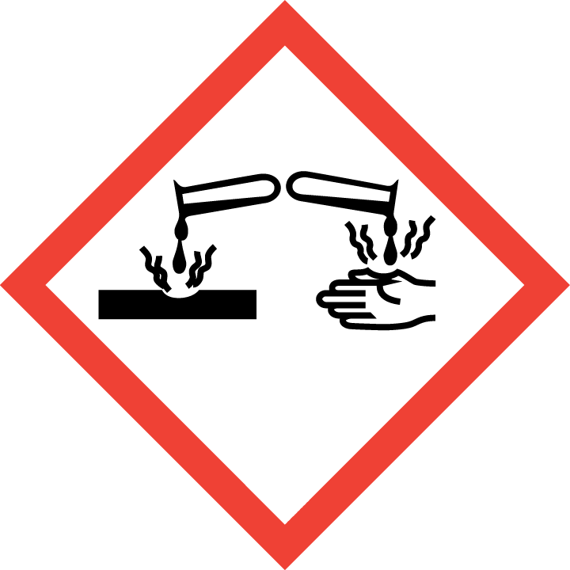 | 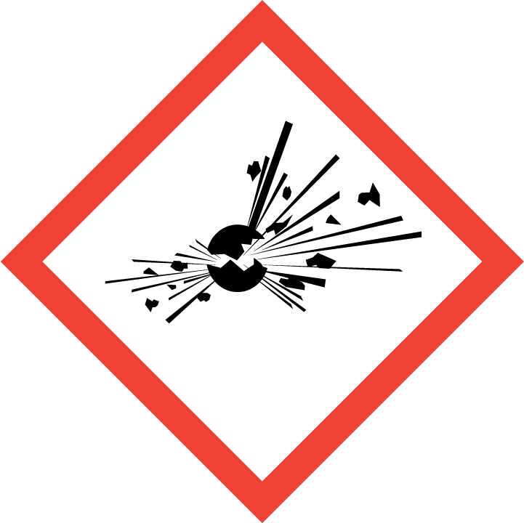 | 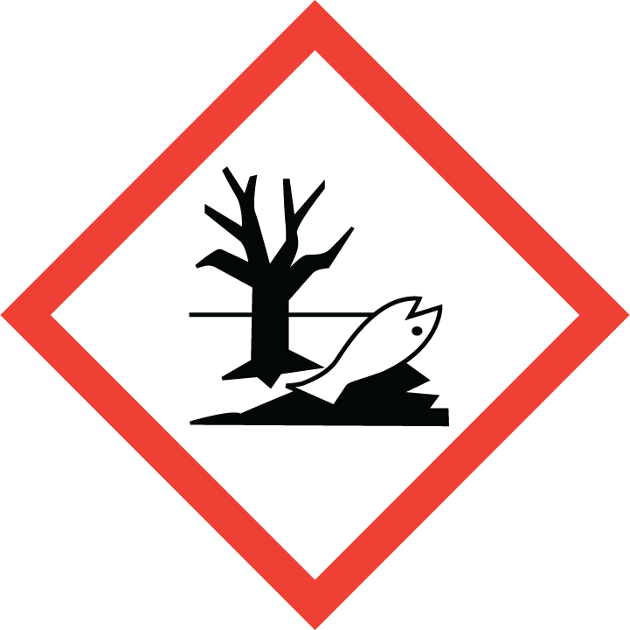 | 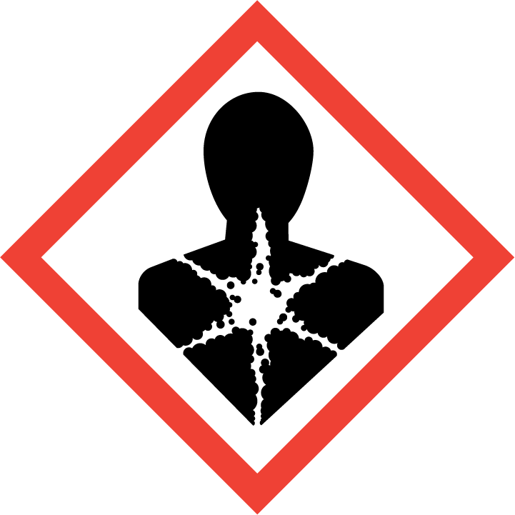
Flammable | Toxic | Harmful | Oxidising | Corrosive | Explosive | Harmful to the environment | Health Hazards i.e. respiratory sensitisation or carcinogenicity
 |  |  |  | 

SMOKING, EATING AND DRINKING ARE PROHIBITED IN THE WORK AREAS.
Information, Instruction and Training must be provided to all users. Young Persons, New or Expectant Mothers and other vulnerable groups must not use or be exposed to this product.

WORKPLACE EXPOSURE LIMITS (WEL’s)
No occupational exposure limits assigned for this product.

IMPORTANT!
Refer to Workplace Exposure Levels information provided in the Manufacturers Safety Data and revise control measures if exposure levels likely to be reached.

ROUTE OF EXPOSURE
Skin |  | Eyes |  | Inhalation | 
Ingestion |  | Cuts/abrasions |  | Systemic

PERSONS AT RISK
User of product |  | Co workers |  | Members of the public

ROUTE OF EXPOSURE | 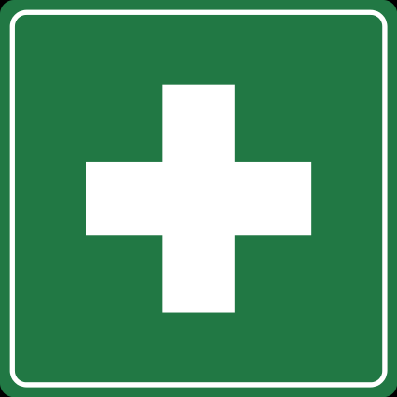  FIRST AID MEASURES
Inhalation | Remove affected person from source of contamination. Move affected person to fresh air and keep warm and at rest in a position comfortable for breathing. If breathing stops provide artificial respiration. Get medical attention if any discomfort continues.
Skin contact | Rinse with plenty of water. Get medical attention if any discomfort continues.
Eye contact | Make sure to remove any contact lenses from the eyes before rinsing. Promptly wash eyes with plenty of water. Continue to rinse for at least 15 minutes. Get medical attention if any discomfort continues.
Ingestion | Do not induce vomiting. Immediately rinse mouth and provide fresh air. Place unconscious person on the side in the recovery position so that breathing continues. Get medical attention if any discomfort continues.
In all cases of doubt, or if symptoms persist seek medical attention. Never give anything by mouth to an unconscious person. If unconscious, place in recovery position and seek medical advice.

PERSONAL PROTECTIVE EQUIPMENT
 |  | 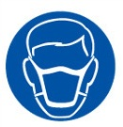 |  | 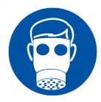 | 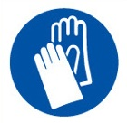 | 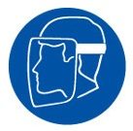
YES | YES | YES/NO |  | YES/NO | YES | YES/NO
 |  |  |  |  | 
YES | YES |  |  |  | YES - Chemical Resistant

HANDLING | STORAGE | TRANSPORT | DISPOSAL
Wear appropriate clothing to prevent any possibility of liquid contact and repeated or prolonged vapour contact. | Keep container tightly closed. Store in a cool well ventilated place between 0 and 40 degrees centigrade. | The product is not covered by international regulations on the transport of dangerous goods | Dispose of waste and residues in accordance with local authority requirements.

REQUIRED CONTROL MEASURES
- Ensure only minimum amounts of urinal blocks are stored on site.
- Ensure approved impermeable gloves are used at all times.
- Ensure overalls are worn and these are suitably laundered.
- Ensure that work is undertaken in well ventilated areas.
- Ensure that workers are equipped with antibacterial hand washes and wipes and that good hygiene practices are enforced.
- Provide workers with suitable barrier creams.

FIRE PRECAUTIONS
This product is not flammable. Use fire-extinguishing media appropriate for surrounding materials.

ACCIDENTAL RELEASE/SPILLAGE PROCEDURES
Collect spillages with a shovel or broom or similar and re-use if possible. Any uncontrolled releases into the water course must be reported to the Enviroment Agency.

MONITORING REQUIREMENTS AND HEALTH SURVEILLANCE
Health surveillance is not in place for workers exposed to this product.

